Data are ususally presented in matrix form.

e.g. shopping list

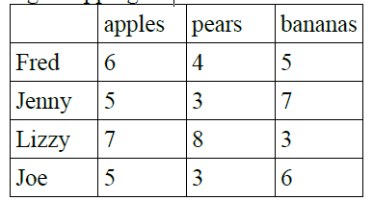

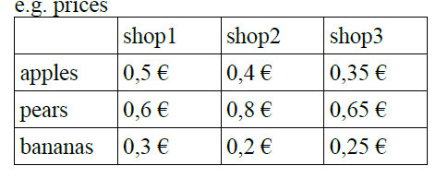

Construct a 4\*3 matrix with a row for each student and a column for each shop, in which

the sum of money is listed, that a student would have to pay in each shop if he buys

verything on his shopping list for the price stated. Where should the students buy their

fruits? What does all this have to do with matrix multiplication?